# EEL 3701 – Digital Logic and Computer Systems

# Report Short Problems 1, 2, 3 and 4

# Greg Bolling

# UF ID 64911960

## Short Problem Statement

The goal of this was to solve three problems, 1, 2, 3 and 4.

## Short Problem 1

The problem 1 solution is as follows, truth table, K-map just incase…

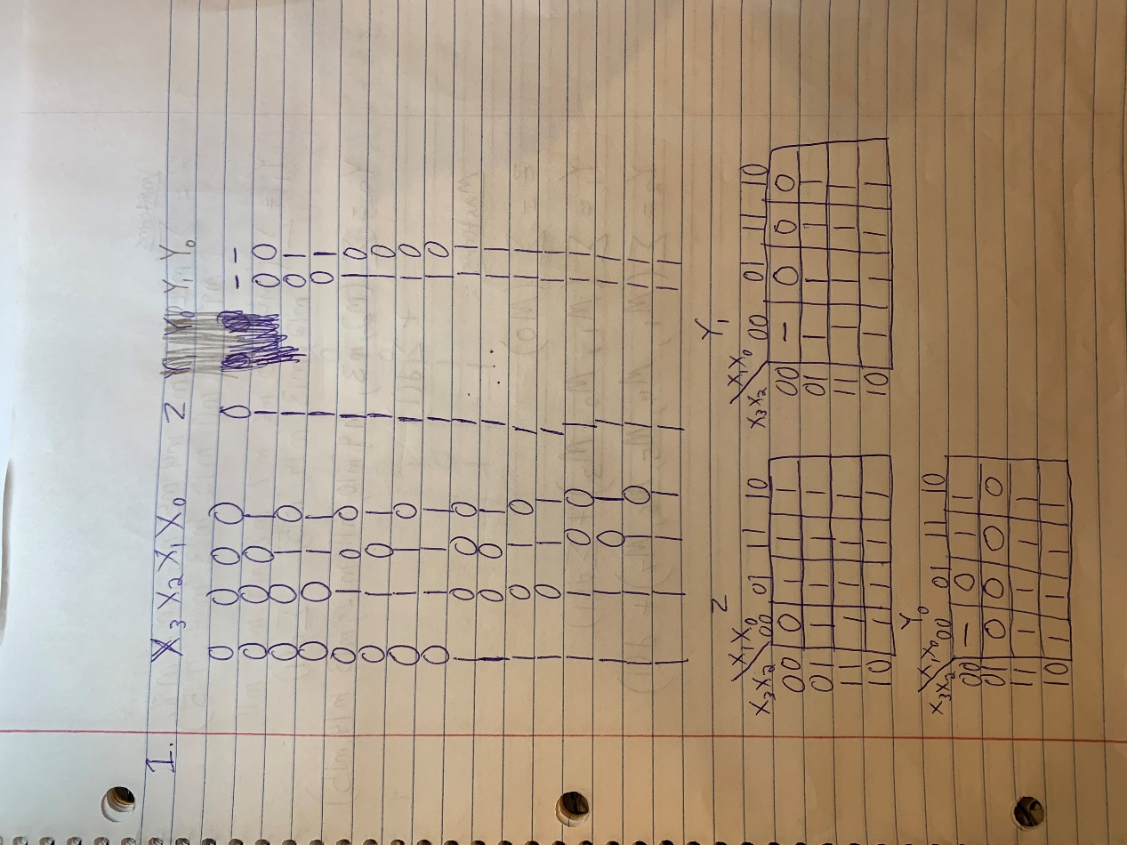

Next, List in decimal form1 the minterms and don’t-care minterms of each output

Next, List in decimal form the maxterms and don’t-care maxterms of each output.

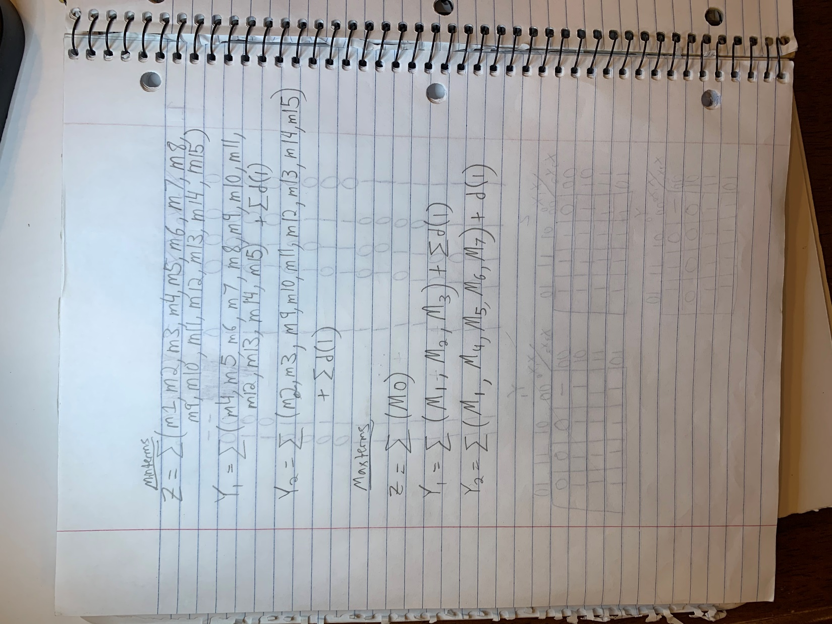

## Short Problem 2

The problem 2 solution is as follows:

Write an equation for the variable Z which is 1 iff the door should open.

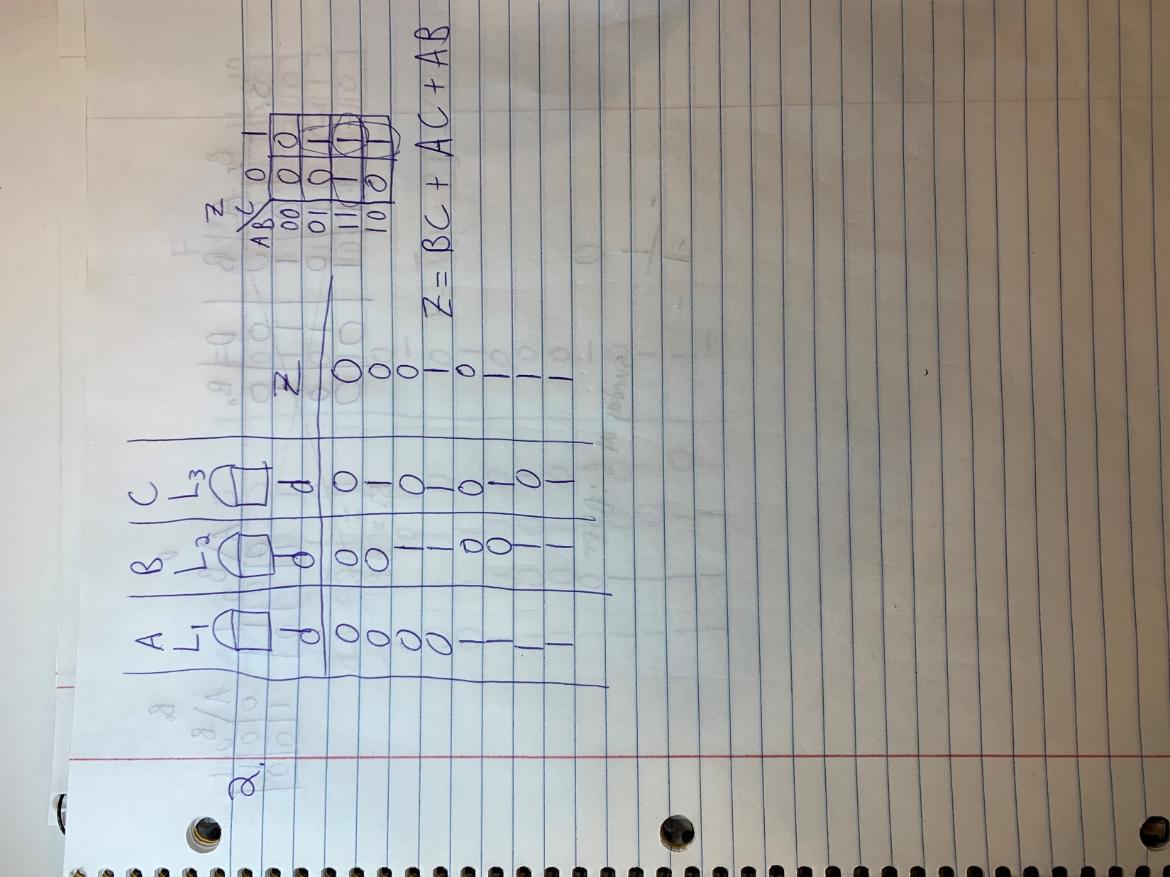

## Short Problem 3

The problem 3 solution is as follows:

Show that a full subtractor can be implemented using two 2-input XOR gates, one inverter, and three 2-input NOR gates.

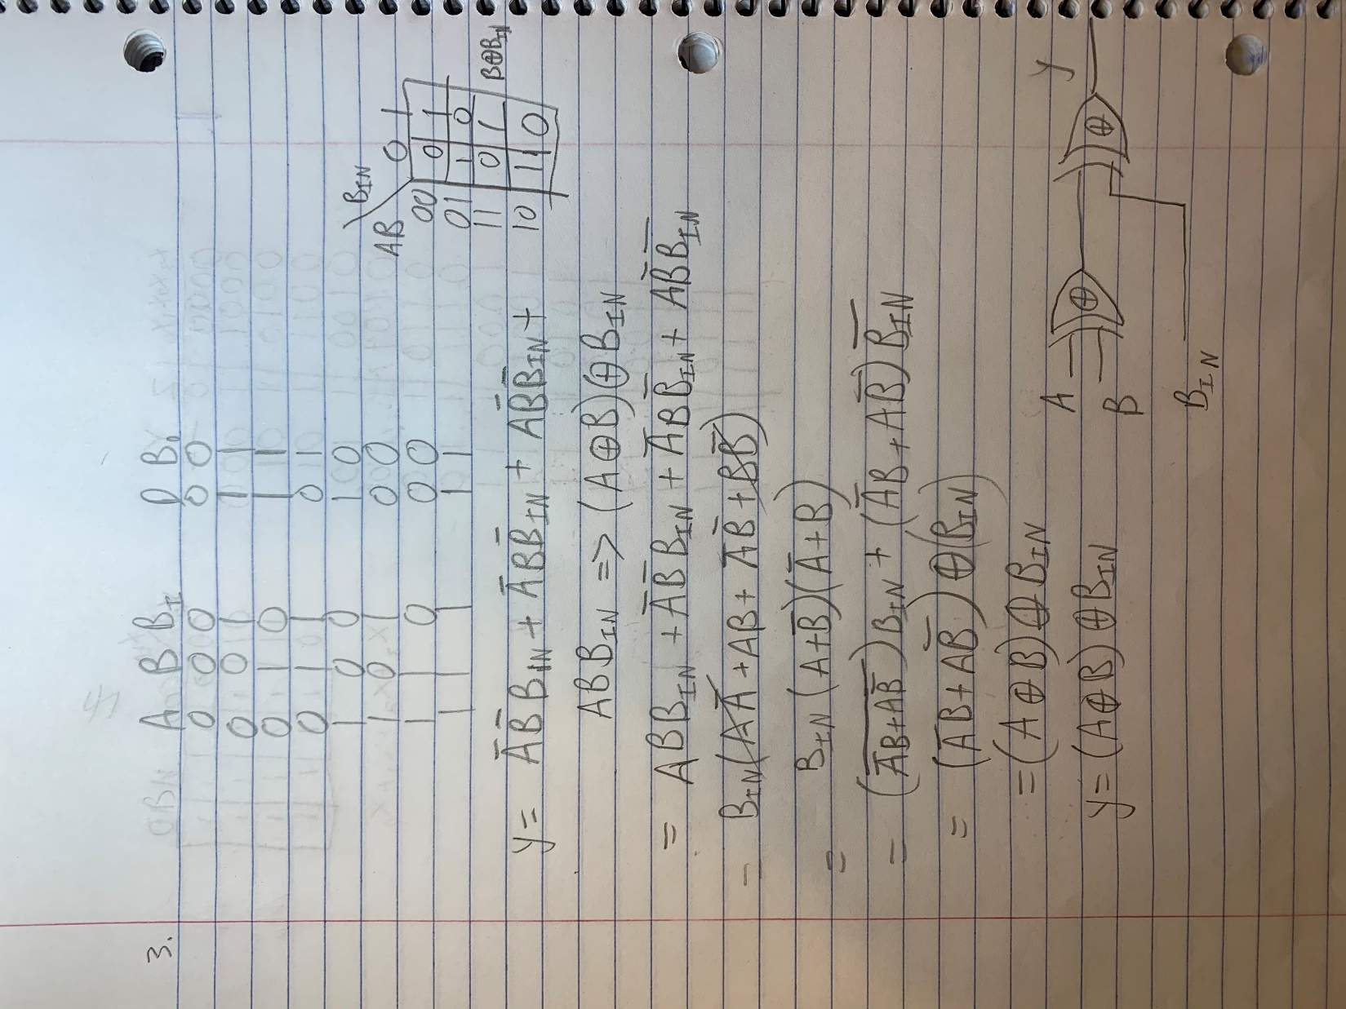

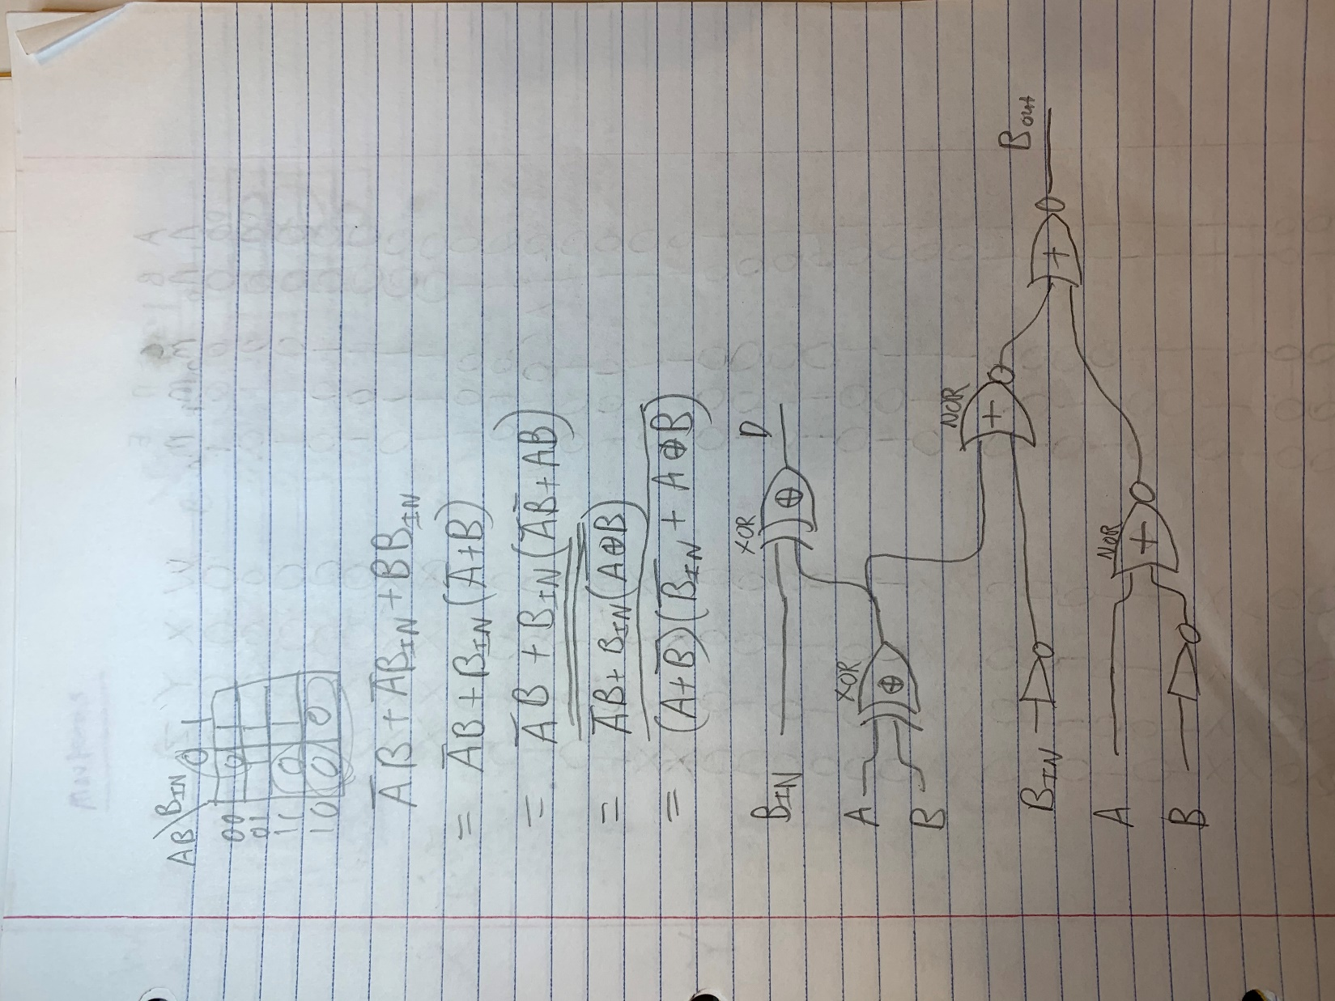

I redrew the schematic so it was more clear.

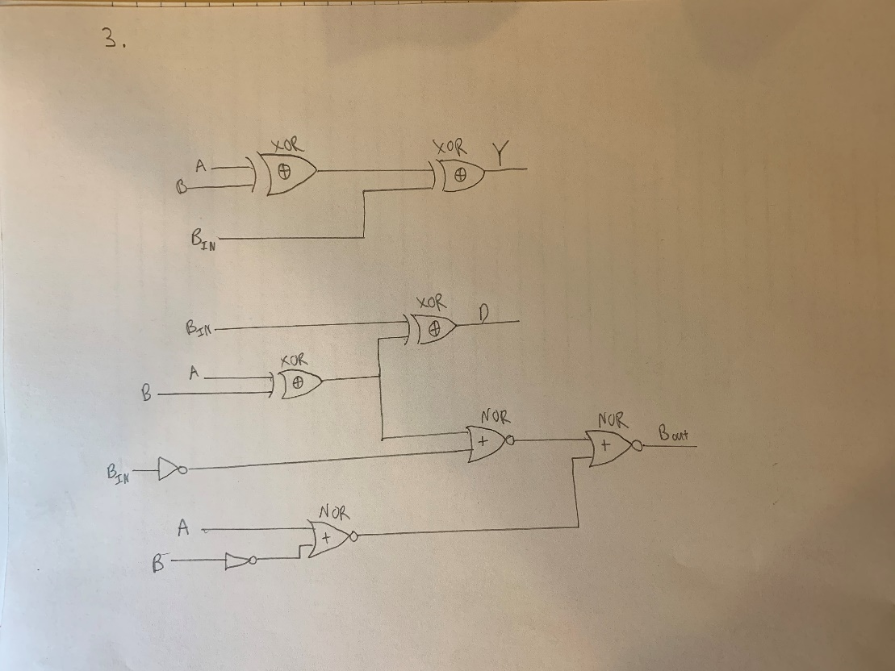

## Short Problem 4

The problem 4 solution is as follows:

